JMX-??????

Safety Assessment Report of

ExHAM Samples for Series Products

(Tanpopo2 QCC-Type Panel)

N/C Jan. 2019

University of Tokyo,

Yokohama National University,

Japan Aerospace Exploration Agency (JAXA)

|  |  |  |  |  |
| --- | --- | --- | --- | --- |
| Document Number  JMX-?????? | | DOCUMENT RELEASE RECORD | PAGE 1 OF 1 | |
| CHANGE/  REVISION | DATE | DESCRIPTION OF CHANGE | | PAGES  AFFECTED |
| NC | Jan.22, 2019 |  | |  |
|  |  |  | |  |
|  |  |  | |  |
|  |  |  | |  |
|  |  |  | |  |

INDEX

1. Introduction 1

1.1. Purpose 1

1.2. Scope 1

2. Safety Analysis Methodology 2

2.1. Methodology 2

2.2. Safety Requirements 2

2.2.1. Applicable Documents 2

3. System Description 3

3.1. Mission Objective 3

3.2. System Description 4

3.3. Structure 6

4. Launch and Return Configuration 11

5. Operations 13

5.1. Ground Operations 13

5.2. On-board Operations 13

5.3. On-board maintenance 14

5.4. Return Operations 14

6. Hazard Report Summary 15

6.1. Safety Analysis Result 15

# Introduction

## Purpose

The purpose of this document is to show the compliance with safety requirements and to show the verification results regarding the hardware and operation to execute “*Understanding of the Lifecycle of Organics in Space (TBD)*” (TNP2QCC [TBD])*[1] installed on ExHAM.

## Scope

This assessment report is prepared for the JAXA and NASA Safety Review on JAXA ExHAM Samples for TNP2QCC.

The scope of the report is for the items of TNP2QCC listed in Table 3-1.

The TNP2QCC Sample is to be launched on Space-X flight in CTB (Cargo Transfer Bag), and will be returned on Space-X. CTB is out of scope of this SAR.

## 

# Safety Analysis Methodology

## Methodology

Hazard analyses in accordance with SSP51700 “Payload Safety Policy and Requirements for the International Space Station” have been evaluated.

## Safety Requirements

### Applicable Documents

* SSP 30599:

Safety Review Process

* SSP 51700 :

Payload Safety Policy and Requirements for the International Space Station

* JMR-002 :

Launch Vehicle Payload Safety Standard

* SSP 50835 :

ISS Pressurized Volume Hardware Common Interface Requirements Document

* P32928-103 :

Requirements for International Partner Cargoes Transported on Russian Progress and Soyuz Vehicles

**2.2.2 Reference Documents**

N/A

# System Description

## Mission Objective

The TNP2QCC exposure panel is one of the samples of Tanpopo2 Mission and will be attached to Exposed Experiment Handhold Attachment Mechanism (ExHAM) and exposed to the Space. The TNP2QCC exposure panel is shared by the following three science themes:

(1) Space exposure of organic matter simulating surfaces of the Solar System small bodies

(2) Space exposure of nitrogen included quenched carbonaceous composites (QNCC)

(3) Space exposure of amino acid and related materials

The first science theme aims to understand the effects of the space environment on organic matter such as space weathering at asteroid surfaces by exposing meteorites and meteorites’ organic matter analogues to the space environment and investigating the structural changes of organic matter in these materials. The second science theme aims to aims to verify the hypothesis that organics which originates in evolved stars have delivered and contributed to primitive organics in solar system by exposing the Quenched Nitrogen-included Carbonaceous Composite (QNCC), the laboratory- synthesized organics that mimics the properties of dust in classical novae, to space environment and by comparing its properties with meteorites' organic matter. The third science theme aims to investigate the stability and structural changes of amino acids and related materials in space exposure environments and to demonstrate what kinds of exogenous amino acids were delivered to the Earth prior to the generation of life. Through these three science themes, we try to understand the lifecycle of organics in space.

## System Description

The TNP2QCC exposure panel will be installed to defined locations in the ExHAM in JEM-PM and transferred to JEM-EF through the Airlock. The ExHAM will be attached to a Handhold with the combination of JEMRMS MA and SFA. After the designated duration of time for the experiments of investigation and demonstration, ExHAM will be detached from the Handhold and taken into the JEM-PM with the combination of JEMRMS MA and SFA. The panel will be detached and will be stored until the return trip to the ground. Detailed investigation of the environmental effects on the specimens, such as degradation mechanism and performance deterioration, will be conducted after bringing the specimens back to the ground.

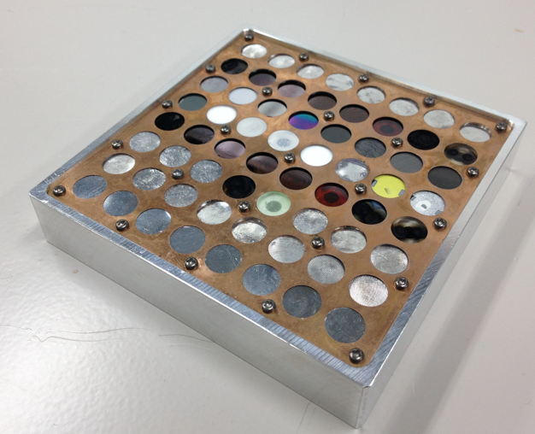

Figure 3-1 TNP2QCC Sample

(Left: without cover, Right: with cover)

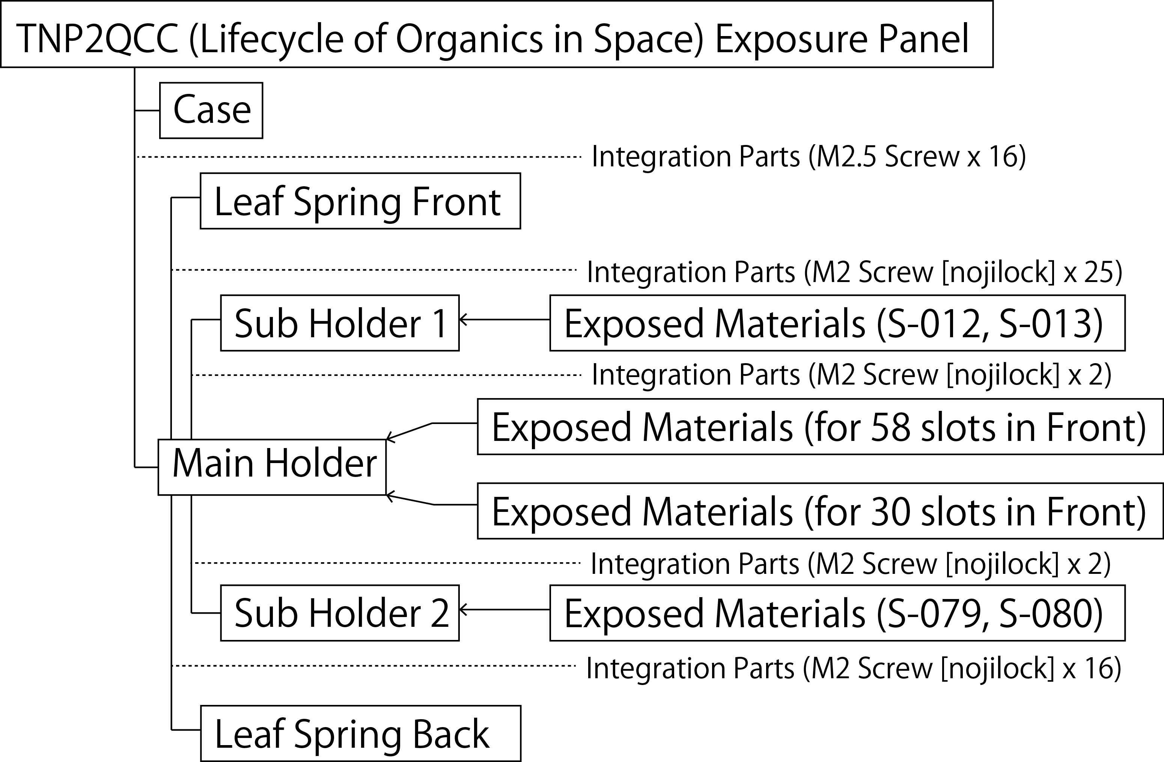

Figure 3-2 Configuration Tree of TNP2QCC

Table 3-1 List of TNP2QCC items

|  |  |  |  |  |
| --- | --- | --- | --- | --- |
| No. | Item | Weight | P/N | Qty. |
| 1 | Tanpopo2 QCC Exposure Panel | < 0.4kg | TNP2QCC | 1 |
| 2 | Tanpopo2 QCC Exposure Panel Lid | < 0.2kg | TNP2QCCLID | 1 |
| 3 | Seal Bag | 15 g | MA-18 | 1 |
| 4 | OC/MC bag [outward] | 15 g | OC/MCBAGOW | 1 |
| 5 | OC/MC bag [homeward] | 15 g | OC/MCBAGHM | 1 |
| 6 | Zeorite Desicant | <100 g | TNP2QCCD | 4 |
| 7 | Bubble Wrap Bag | 50 g | TNP2QCCBWBG | 1 |

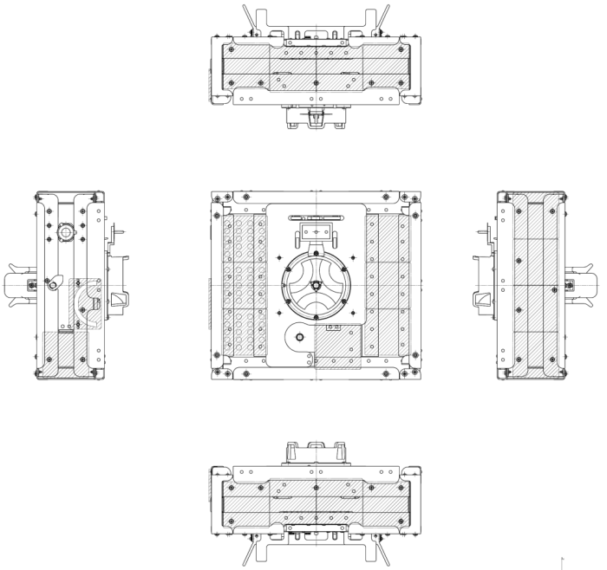

TNP2QCC Sample

100mm x 100mm x 20mm

Figure 3-3 Mounting position of ExHAM #1

## Structure

TNP2QCC Exposure Panel has a simple box-shape structure with no mechanical part.

TNP2QCC Sample consists of following items

- Exposed Materials: ø10mm, thickness 0.5mm—2.0mm, Materials are deposited on a Si substrate or crimped and fixed on a In/Au substrate.

- Case: 100mm x100mm x 20mm aluminum frame to support the holder

- Main Holder: 90mm x 90mm x 3.5mm aluminum plate with 58/30 slots in the front/back

- Sub Holder 1: 11mm x 35mm x 3.5mm aluminum plate with 2 slots

- Sub Holder 2: 22mm x 35mm x 3.5mm aluminum plate with 2 slots

- Leaf Spring Front: 94mm x 94mm x 0.1mm Phosphor bronze with 64 ø8mm holes

- Leaf Spring Back: 72mm x 72mm x 0.1mm Phosphor bronze with 36 ø8mm holes

- 16 stainless M2.5 steel screw threads to tighten main holder and case

- 41 stainless M2 steel screw threads to tighten main holder and the leaf springs

- 4 stainless M2 steel screw threads to tighten main holder and sub holders

Fig 3-4 shows the overview and Fig 3-5 shows the drawing of TNP2QCC Sample. Table 3-2 shows the detailed information of slots for exposed materials (S001-S064) and for non-exposed materials (S065-S100) of TNP2QCC Sample. Table 3-3 shows the structural parts of TNP2QCC Sample. The information of the exposed samples and non-exposed samples are given in Tables 3-4 and 3-5, respectively.

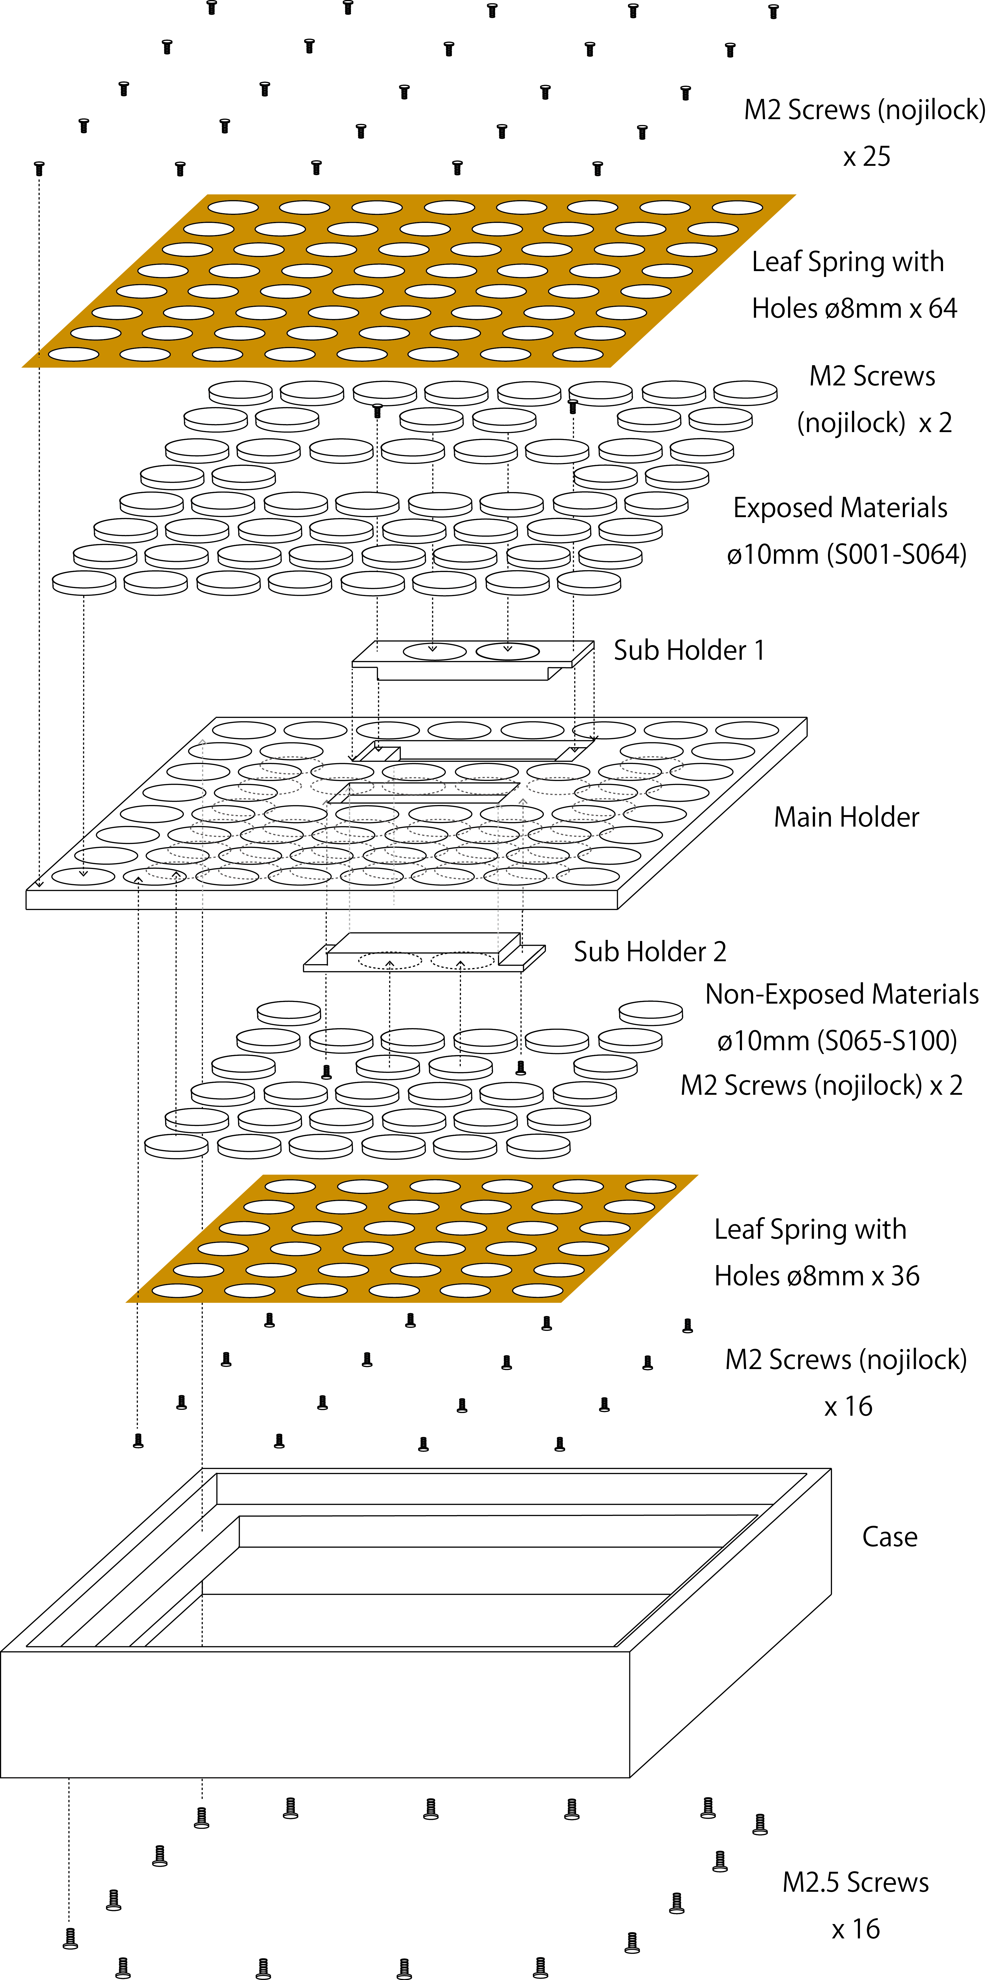

Figure 3-4 Schematic of TNP2QCC Sample

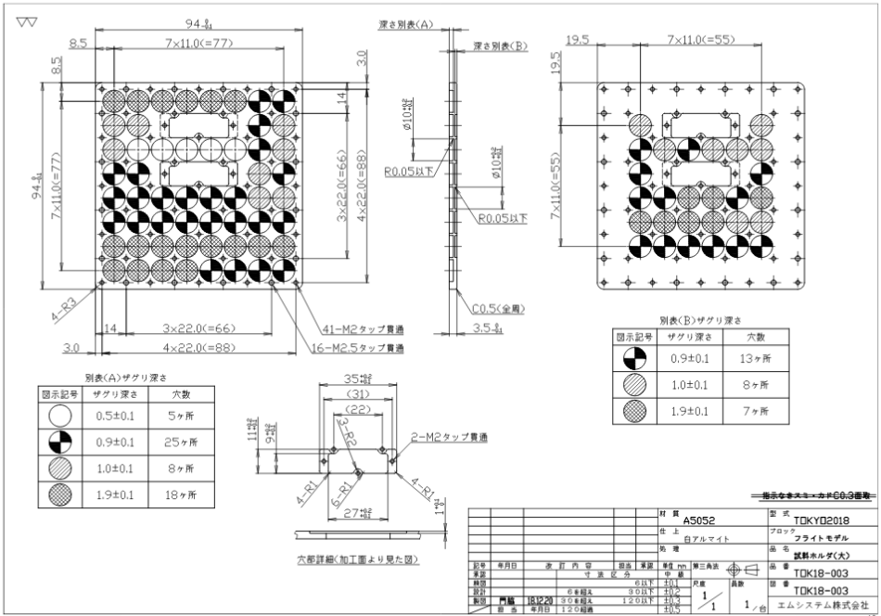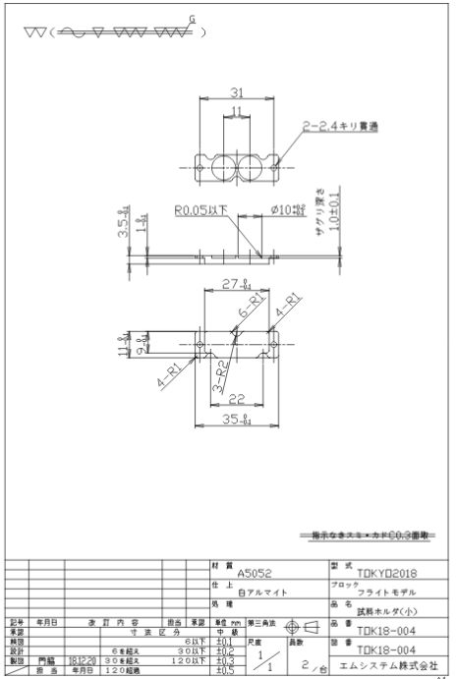

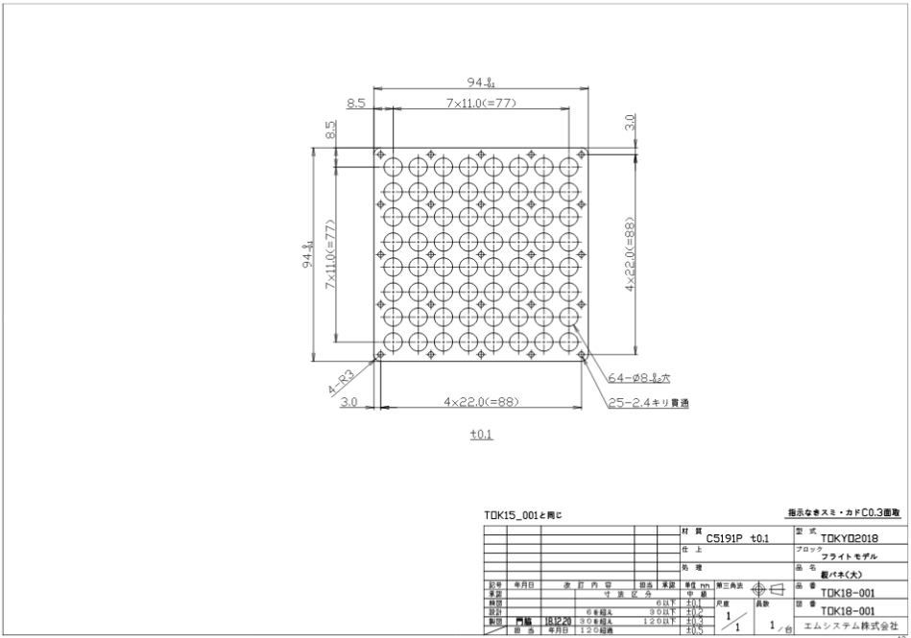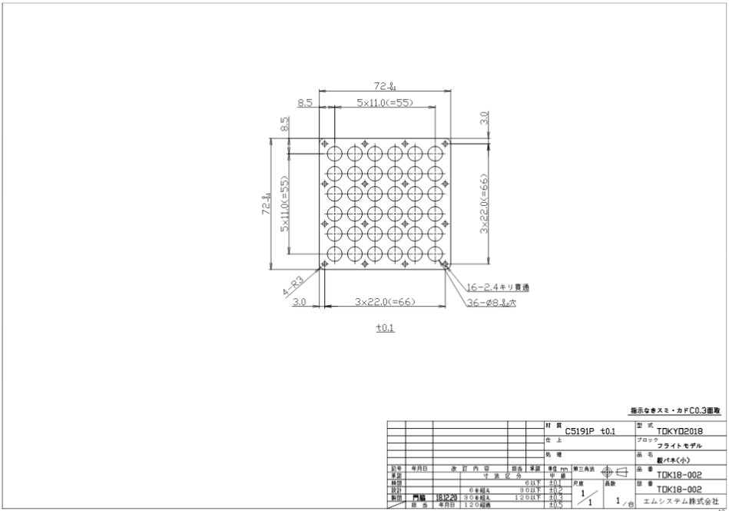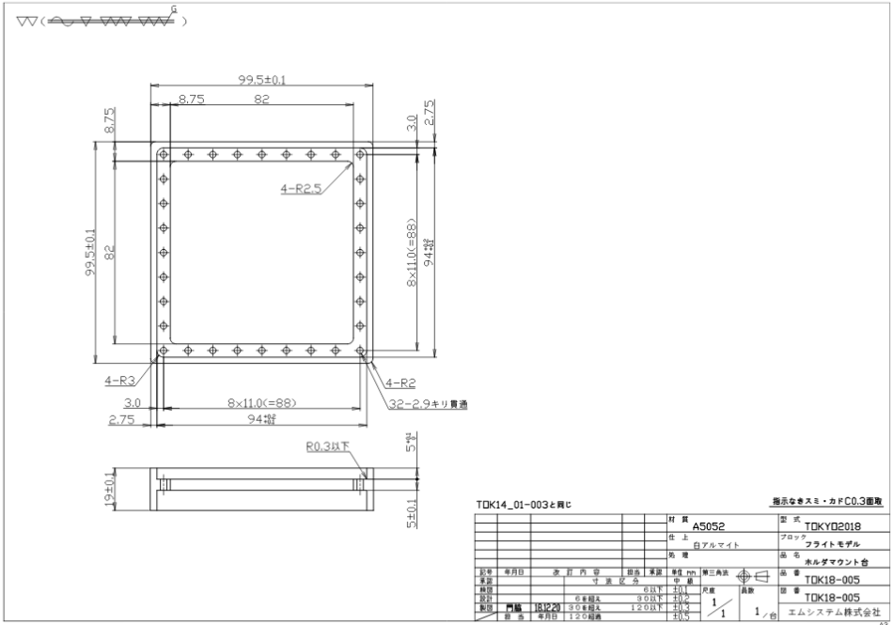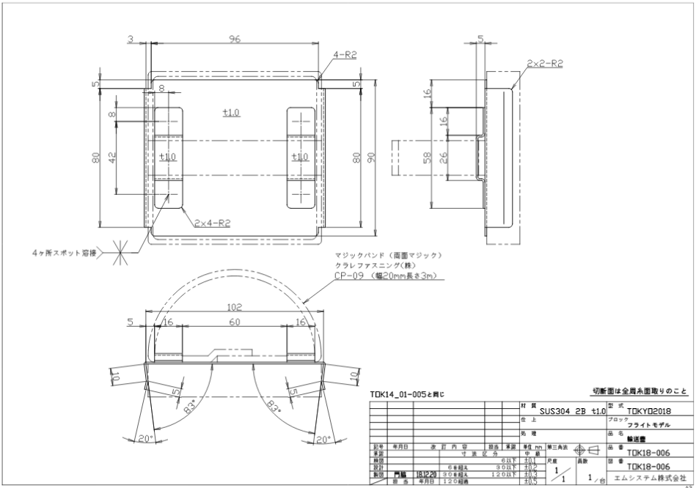

Figure 3-5 Drawing of Constituents of the TNP2QCC Sample; TNP2QCC Exposure Panel (Main Holder, Sub Holders 1&2, Leaf Springs, Case) and TNP2 QCC Exposure Panel Lid

Table 3-2 Major properties of TNP2QCC Sample

|  |  |
| --- | --- |
| Item | Specification |
| Size | 100 x 100 x 20mm (Type 1) |
| Mass | < 250g |
| Exposed Material | 58 slots per Sample  with additional 30 slots for non-exposed materials  (See Table 3-4.) |

Table 3-3 Structural parts of TNP2QCC Sample

|  |  |  |  |
| --- | --- | --- | --- |
| No. | Part Name | Material | Surface Treatment etc. |
| 1 | Case | A5052-H34 | Anode oxide coating MIL-A-8625 TYPE II Class1 |
| 2 | Main Holder | A5052-H34 | Anode oxide coating MIL-A-8625 TYPE II Class1 |
| 3 | Sub Hoder 1 | A5052-H34 | Anode oxide coating MIL-A-8625 TYPE II Class1 |
| 4 | Sub Holder 2 | A5052-H34 | Anode oxide coating MIL-A-8625 TYPE II Class1 |
| 3 | Leaf Spring Front | C5191P | - |
| 4 | Leaf Spring Back | C5191P | - |
| 4 | Screw (nojilock) | SUS304 | M2 |
| 5 | Screw | SUS304 | M2.5 |

Table 3-4 Exposed Material of TNP2QCC Sample (1/4)

|  | No. | Material | Mass |
| --- | --- | --- | --- |
| (1) | S-001s | Si Substrate | 200mg |
| S-001 | Filmy Quenched Carbonaceous Composite | <10mg |
| S-001c | MgF2 Cover | 200mg |
| (2) | S-002s | Si Substrate | 200mg |
| S-002 | Nitrogen-included Quenched Carbonaceous Composite A | <10mg |
| S-002c | MgF2 Cover | 200mg |
| (3) | S-003s | Si Substrate | 200mg |
| S-003 | Nitrogen-included Quenched Carbonaceous Composite B | <10mg |
| S-003c | MgF2 Cover | 200mg |
| (4) | S-004s | Si Substrate | 200mg |
| S-004 | Nitrogen-included Quenched Carbonaceous Composite C | <10mg |
| S-004c | MgF2 Cover | 200mg |
| (5) | S-005s | Si Substrate | 200mg |
| S-005 | Nitrogen-included Quenched Carbonaceous Composite D | <10mg |
| S-005c | MgF2 Cover | 200mg |
| (6) | S-006s | Si Substrate | 200mg |
| S-006 | Nitrogen-included Quenched Carbonaceous Composite E | <10mg |
| S-006c | MgF2 Cover | 200mg |
| (7) | S-007s | Indium t-1mm | 610mg |
| S-007 | Murchison Meteorite (natural stone) | <5mg |
| (8) | S-008s | Indium t-1mm | 610mg |
| S-008 | Orgueil Meteorite (natural stone) | <5mg |
| (9) | S-009s | Au t-0.1mm | 140mg |
| S-009 | Murchison Meteorite (natural stone) | <5mg |
| S-009c | MgF2 Cover | 200mg |
| (10) | S-010s | Au t-0.1mm | 140mg |
| S-010 | Orgueil Meteorite (natural stone) | <5mg |
| S-010c | MgF2 Cover | 200mg |
| (11) | S-015s | Indium t-1mm | 610mg |
| S-015 | Tagish Lake Meteorite (natural stone) | <5mg |
| (12) | S-016s | Au t-0.1mm | 140mg |
| S-016 | Tagish Lake Meteorite (natural stone) | <5mg |
| S-016c | MgF2 Cover | 200mg |
| (13) | S-017s | Au t-0.1mm | 140mg |
| S-017 | Humic Acid | <5mg |
| S-017c | MgF2 Cover | 200mg |
| (14) | S-018s | Au t-0.1mm | 140mg |
| S-018 | Murchison Meteorite (natural stone) | <5mg |
| S-018c | Al Spacer t-0.5mm | 110mg |
| (15) | S-019s | Au t-0.1mm | 140mg |
| S-019 | Orgueil Meteorite (natural stone) | <5mg |
| S-019c | Al Spacer t-0.5mm | 110mg |
| (16) | S-020s | Au t-0.1mm | 140mg |
| S-020 | Tagish Lake (natural stone) | <5mg |
| S-020c | Al Spacer t-0.5mm | 110mg |

Table 3-4 Exposed Material of TNP2QCC Sample (2/4)

|  | No. | Material | Mass |
| --- | --- | --- | --- |
| (17) | S-021s | Au t-0.1mm | 140mg |
| S-021 | Humic Acid | <5mg |
| S-021c | Al Spacer t-0.5mm | 110mg |
| (18) | S-022s | Au t-0.1mm | 140mg |
| S-022 | Meteorite Insoluble Organic Matter Analog | <5mg |
| S-022c | Al Spacer t-0.5mm | 110mg |
| (19) | S-023s | Indium t-1mm | 610mg |
| S-023 | Humic Acid | <5mg |
| (20) | S-024s | Au t-0.1mm | 140mg |
| S-024 | Meteorite Insoluble Organic Matter Analog | <5mg |
| S-024c | MgF2 Cover | 200mg |
| (21) | S-025s | Al spacer t-0.04mm | 10mg |
| S-025 | Cu TEM Grid (d-3mm, t-0.04mm) | 10mg |
| S-025c | MgF2 Cover | 200mg |
| (22) | S-026s | Indium t-1mm | 610mg |
| S-026 | Meteorite Insoluble Organic Matter Analog | <5mg |
| (23) | S-028 | Murchison Meteorite (natural stone) | <100mg |
| S-028c | MgF2 Cover | 200mg |
| (24) | S-029 | Humic Acid | <100mg |
| S-029c | MgF2 Cover | 200mg |
| (25) | S-031s | In t-0.1mm | 61mg |
| S-031 | Murchison Meteorite (natural stone) | <5mg |
| S-031c | MgF2 Cover | 200mg |
| (26) | S-032s | Al spacer t-0.04mm | 10mg |
| S-032 | Cu TEM Grid (d-3mm, t-0.04mm) | 10mg |
| S-032c | MgF2 Cover | 200mg |
| (27) | S-033s | Si Substrate | 200mg |
| S-033 | Filmy Quenched Carbonaceous Composite | <10mg |
| (28) | S-034s | Si Substrate | 200mg |
| S-034 | Nitrogen-included Quenched Carbonaceous Composite A | <10mg |
| (29) | S-035s | Si Substrate | 200mg |
| S-035 | Nitrogen-included Quenched Carbonaceous Composite B | <10mg |
| (30) | S-036s | Si Substrate | 200mg |
| S-036 | Nitrogen-included Quenched Carbonaceous Composite C | <10mg |
| (31) | S-037s | Si Substrate | 200mg |
| S-037 | Nitrogen-included Quenched Carbonaceous Composite D | <10mg |
| (32) | S-038s | Si Substrate | 200mg |
| S-038 | Nitrogen-included Quenched Carbonaceous Composite E | <10mg |
| (33) | S-039s | In t-0.1mm | 61mg |
| S-039 | Orgueil Meteorite (natural stone) | <5mg |
| S-039c | MgF2 Cover | 200mg |
| (34) | S-040s | In t-0.1mm | 61mg |
| S-040 | Tagish Lake Meteorite (natural stone) | <5mg |
| S-040c | MgF2 Cover | 200mg |

Table 3-4 Exposed Material of TNP2QCC Sample (3/4)

|  | No. | Material | Mass |
| --- | --- | --- | --- |
| (35) | S-041s | Si Substrate | 200mg |
| S-041 | Filmy Quenched Carbonaceous Composite | <10mg |
| (36) | S-042s | Si Substrate | 200mg |
| S-042 | Nitrogen-included Quenched Carbonaceous Composite A | <10mg |
| (37) | S-043s | Si Substrate | 200mg |
| S-043 | Nitrogen-included Quenched Carbonaceous Composite B | <10mg |
| (38) | S-044s | Si Substrate | 200mg |
| S-044 | Nitrogen-included Quenched Carbonaceous Composite C | <10mg |
| (39) | S-045s | Si Substrate | 200mg |
| S-045 | Nitrogen-included Quenched Carbonaceous Composite D | <10mg |
| (40) | S-046s | Si Substrate | 200mg |
| S-046 | Nitrogen-included Quenched Carbonaceous Composite E | <10mg |
| (41) | S-047s | Si Substrate | 200mg |
| S-047 | Glycine | 5mg |
| (42) | S-048s | Si Substrate | 200mg |
| S-048 | Glycine | 5mg |
| (43) | S-049s | Si Substrate | 200mg |
| S-049 | Glycine | 5mg |
| S-049c | MgF2 Cover | 200mg |
| (44) | S-050s | Si Substrate | 200mg |
| S-050 | Glycine | 5mg |
| S-050c | MgF2 Cover | 200mg |
| (45) | S-051s | Si Substrate | 200mg |
| S-051 | Glycine | 5mg |
| S-051c | SiO2 Cover | 200mg |
| (46) | S-052s | Si Substrate | 200mg |
| S-052 | Glycine | 5mg |
| S-052c | SiO2 Cover | 200mg |
| (47) | S-053s | Si Substrate | 200mg |
| S-053 | Simulated Interstellar Organics A | 5mg |
| S-053c | MgF2 Cover | 200mg |
| (48) | S-054s | Si Substrate | 200mg |
| S-054 | Simulated Interstellar Organics B | 5mg |
| S-054c | MgF2 Cover | 200mg |
| (49) | S-055s | Si Substrate | 200mg |
| S-055 | Simulated Interstellar Organics C | 5mg |
| S-055c | MgF2 Cover | 200mg |
| (50) | S-056s | Si Substrate | 200mg |
| S-056 | Simulated Interstellar Organics D | 5mg |
| S-056c | MgF2 Cover | 200mg |

Table 3-4 Exposed Material of TNP2QCC Sample (4/4)

|  | No. | Material | Mass |
| --- | --- | --- | --- |
| (51) | S-057s | Si Substrate | 200mg |
| S-057 | Simulated Interstellar Organics A | 5mg |
| S-057c | SiO2 Cover | 200mg |
| (52) | S-058s | Si Substrate | 200mg |
| S-058 | Simulated Interstellar Organics B | 5mg |
| S-058c | SiO2 Cover | 200mg |
| (53) | S-059s | Si Substrate | 200mg |
| S-059 | Simulated Interstellar Organics C | 5mg |
| S-059c | SiO2 Cover | 200mg |
| (54) | S-060s | Si Substrate | 200mg |
| S-060 | Simulated Interstellar Organics D | 5mg |
| S-060c | SiO2 Cover | 200mg |
| (55) | S-061s | Si Substrate | 200mg |
| S-061 | Simulated Interstellar Organics A | 5mg |
| (56) | S-062s | Si Substrate | 200mg |
| S-062 | Simulated Interstellar Organics B | 5mg |
| (57) | S-063s | Si Substrate | 200mg |
| S-063 | Simulated Interstellar Organics C | 5mg |
| (58) | S-064s | Si Substrate | 200mg |
| S-064 | Simulated Interstellar Organics D | 5mg |

Table 3-5 Non-Exposed Material of TNP2QCC Sample (1/3)

|  | No. | Material | Mass |
| --- | --- | --- | --- |
| (1) | S-065s | In t-0.1mm | 61mg |
| S-065 | Murchison Meteorite (natural stone) | <5mg |
| S-065c | MgF2 Cover | 200mg |
| (2) | S-067 | Murchison Meteorite (natural stone) | <100mg |
| S-067c | MgF2 Cover | 200mg |
| (3) | S-068 | Humic Acid | <100mg |
| S-068c | MgF2 Cover | 200mg |
| (4) | S-070s | In t-0.1mm | 61mg |
| S-070 | Orgueil Meteorite (natural stone) | <5mg |
| S-070c | MgF2 Cover | 200mg |
| (5) | S-071s | Al spacer t-0.04mm | 10mg |
| S-071 | Cu TEM Grid (d-3mm, t-0.04mm) | 10mg |
| S-071c | MgF2 Cover | 200mg |
| (6) | S-072s | In t-0.1mm | 61mg |
| S-072 | Tagish Lake Meteorite (natural stone) | <5mg |
| S-072c | MgF2 Cover | 200mg |
| (7) | S-073s | Al spacer t-0.04mm | 10mg |
| S-073 | Cu TEM Grid (d-3mm, t-0.04mm) | 10mg |
| S-073c | MgF2 Cover | 200mg |
| (8) | S-074s | Au t-0.1mm | 140mg |
| S-074 | Murchison Meteorite (natural stone) | <5mg |
| S-074c | MgF2 Cover | 200mg |

Table 3-5 Non-Exposed Material of TNP2QCC Sample (2/3)

|  | No. | Material | Mass |
| --- | --- | --- | --- |
| (9) | S-075s | Au t-0.1mm | 140mg |
| S-075 | Orgueil Meteorite (natural stone) | <5mg |
| S-075c | MgF2 Cover | 200mg |
| (10) | S-076s | Au t-0.1mm | 140mg |
| S-076 | Tagish Lake Meteorite (natural stone) | <5mg |
| S-076c | MgF2 Cover | 200mg |
| (11) | S-077s | Si Substrate | 200mg |
| S-077 | Glycine | 5mg |
| (12) | S-082s | Si Substrate | 200mg |
| S-082 | Glycine | 5mg |
| (13) | S-083s | Si Substrate | 200mg |
| S-083 | Filmy Quenched Carbonaceous Composite | <10mg |
| (14) | S-084s | Si Substrate | 200mg |
| S-084 | Filmy Quenched Carbonaceous Composite | <10mg |
| (15) | S-085s | Si Substrate | 200mg |
| S-085 | Filmy Quenched Carbonaceous Composite | <10mg |
| S-085c | MgF2 Cover | 200mg |
| (16) | S-086s | Si Substrate | 200mg |
| S-086 | Filmy Quenched Carbonaceous Composite | <10mg |
| S-086c | MgF2 Cover | 200mg |
| (17) | S-087s | Si Substrate | 200mg |
| S-087 | Nitrogen-included Quenched Carbonaceous Composite A | <10mg |
| (18) | S-088s | Si Substrate | 200mg |
| S-088 | Nitrogen-included Quenched Carbonaceous Composite A | <10mg |
| S-088c | MgF2 Cover | 200mg |
| (19) | S-089s | Si Substrate | 200mg |
| S-089 | Glycine | 5mg |
| S-089c | MgF2 Cover | 200mg |
| (20) | S-090s | Si Substrate | 200mg |
| S-090 | Glycine | 5mg |
| S-090c | SiO2 Cover | 200mg |
| (21) | S-091s | Si Substrate | 200mg |
| S-091 | Simulated Interstellar Organics A | 5mg |
| S-091c | MgF2 Cover | 200mg |
| (22) | S-092s | Si Substrate | 200mg |
| S-092 | Simulated Interstellar Organics A | 5mg |
| S-092c | SiO2 Cover | 200mg |
| (23) | S-093s | Au t-0.1mm | 140mg |
| S-093 | Humic Acid | <5mg |
| S-093c | MgF2 Cover | 200mg |
| (24) | S-094s | Au t-0.1mm | 140mg |
| S-094 | Meteorite Insoluble Organic Matter Analog | <5mg |
| S-094c | MgF2 Cover | 200mg |

Table 3-5 Non-Exposed Material of TNP2QCC Sample (3/3)

|  | No. | Material | Mass |
| --- | --- | --- | --- |
| (25) | S-095s | Si Substrate | 200mg |
| S-095 | Glycine | 5mg |
| (26) | S-096s | Si Substrate | 200mg |
| S-096 | Glycine | 5mg |
| (27) | S-097s | Si Substrate | 200mg |
| S-097 | Simulated Interstellar Organics A | 5mg |
| (28) | S-098s | Si Substrate | 200mg |
| S-098 | Simulated Interstellar Organics B | 5mg |
| (29) | S-099s | Si Substrate | 200mg |
| S-099 | Simulated Interstellar Organics C | 5mg |
| (30) | S-100s | Si Substrate | 200mg |
| S-100 | Simulated Interstellar Organics D | 5mg |

# Launch and Return Configuration

Configuration for launch for TNP2QCC Sample is summarized in Table 4-1 and Fig. 4-1 and that for return is in Table 4-2 and Fig.4-2. In the configuration for launch, a bubble wrap bag contains one sample packed in Preservation Bag [outward] stowed in a Seal Bag and a Preservation Bag [homeword] (kept unopened). In the configuration for return, a bubble wrap bag contains one sample packed in Preservation Bag [homeward] stowed in a Seal Bag.

Table 4-1 Launch Configuration of TNP2QCC Sample

|  |  |  |  |  |
| --- | --- | --- | --- | --- |
| **No** | **Item** | **P/N** | **Quantity** | **Remarks** |
| 1 | Seal Bag | MA-18 | 1 | Preservation Bag [outward] inside |
| 2 | Preservation Bag  [outward] | OC/MCBAGOW | 1 | Sample inside |
| 3 | Preservation Bag  [homeward] | OC/MCBAGHW | 1 | Kept unopened |
| 4 | Bubble Wrap bag | TNP2QCCBWBG | 1 | Seal Bag and Preservation Bag [homeward] inside |

Table 4-2 Return Configuration of TNP2QCC Sample

|  |  |  |  |  |
| --- | --- | --- | --- | --- |
| **No** | **Item** | **P/N** | **Quantity** | **Remarks** |
| 1 | Seal Bag | MA-18 | 1 | Preservation Bag [homeward] inside |
| 2 | Preservation Bag  [homeward] | OC/MCBAGHW | 1 | Sample inside |
| 3 | Bubble Wrap bag | TNP2QCCBWBG | 1 | Seal Bag inside |

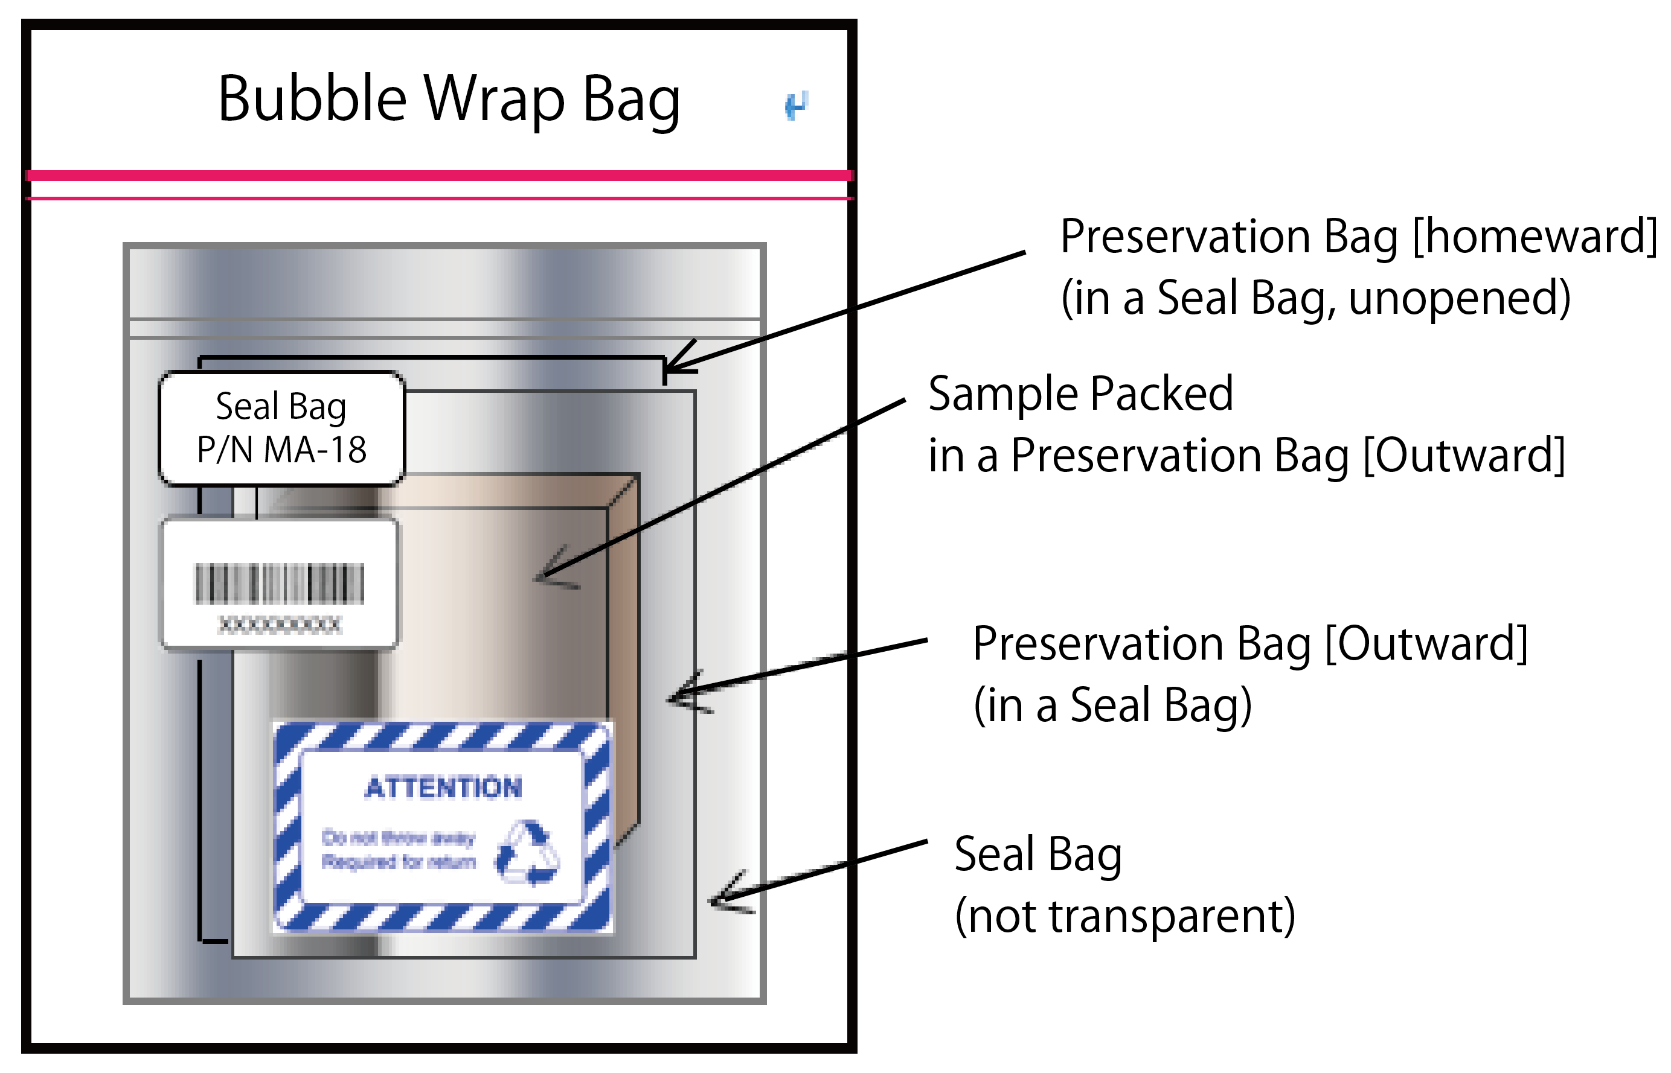

Figure 4-1 Launch Configuration of TNP2QCC Sample

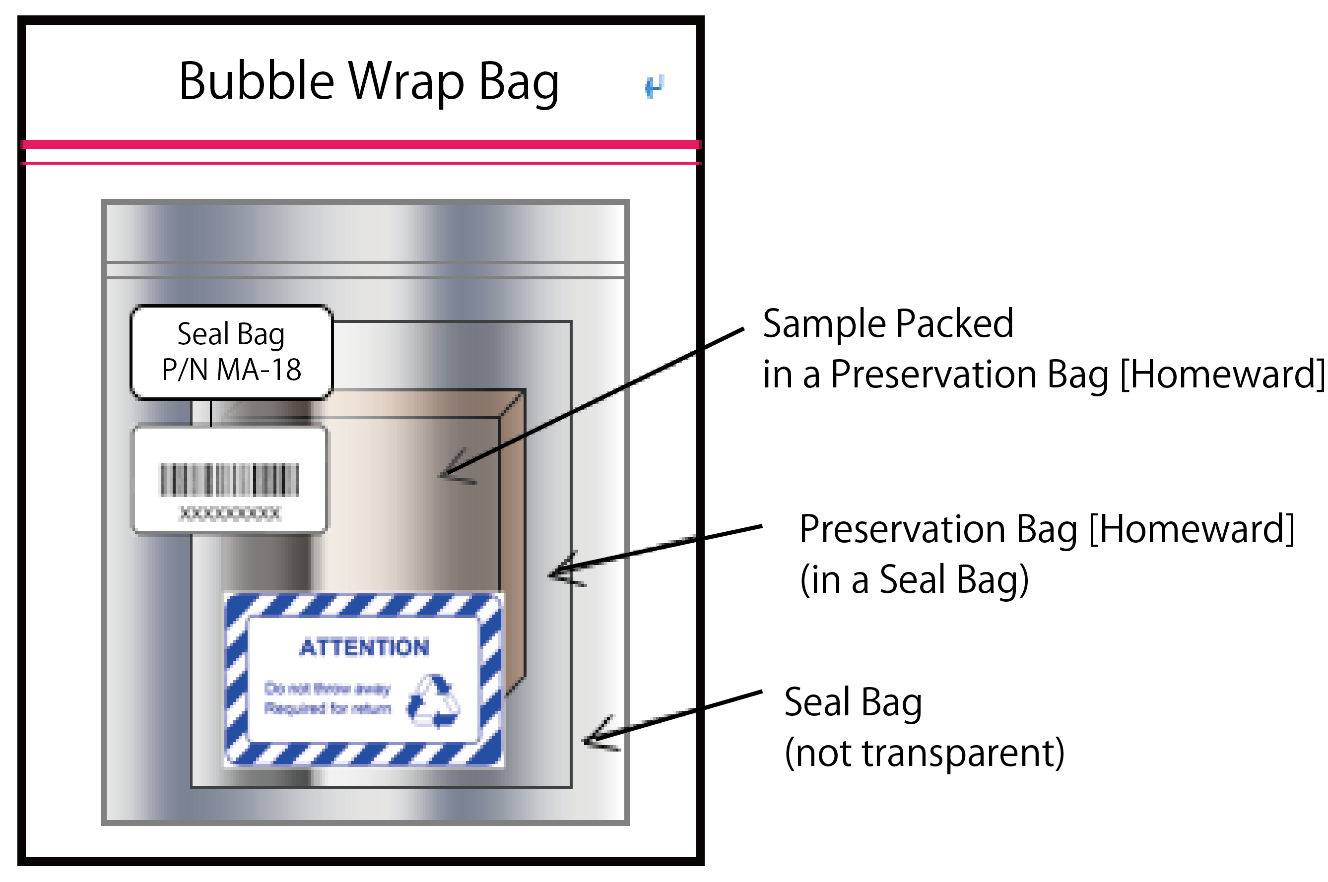

Figure 4-2 Return Configuration of TNP2QCC Sample

# Operations

The ExHAM Samples will be installed to the ExHAM. The samples attached on the ExHAM are exposed to space environment at JEM-EF. The samples are removed at which the ExHAM is transferred to JEM cabin about once a year. Then samples will be exposed in space environment based on each experiment. The detached samples are stored in the stowage and return to earth by Space-X or Soyuz.

## Ground Operations

No launch site operation is planned for the ExHAM Samples

## On-board Operations

(1) Preparation

[IVA]

1. Set ExHAM on the table of the Airlock.
2. Take the all samples from the bags.
3. Attach the all type of samples on the ExHAM. *1)
4. Remove the cover from sample. *2)
5. Take photos of all of the faces of ExHAM in JEM cabin to record the secure attachment, direction against the ExHAM, and the condition of samples.
6. All of bags are stored until the recovery of the samples from ExHAM.
7. Downlink the photo data.

Note: *1) Attaching samples on the ExHAM has been described by ExHAM Safety Analysis Report.

*2) For QCC Sample, the cover is removed just before attaching the sample on ExHAM.

(2) Experiment

[IVA] Setting of ExHAM *3)

1. Transfer ExHAM through the Airlock.
2. Remove ExHAM from the Airlock with the combination of JEMRMS MA and SFA.
3. Set ExHAM on a handhold.

Note: *3) Setting of ExHAM has been described by ExHAM Safety Analysis Report.

## On-board maintenance

There is no planned maintenance operation on-board.

## Return Operations

(1) Recovery Operation

[IVA] Recovery of ExHAM and ExHAM samples

1. Remove ExHAM from the handhold with the combination of JEMRMS MA and SFA.
2. Attach ExHAM on the Airlock Table.
3. Transfer ExHAM on the Airlock Table to JEM cabin through Airlock.
4. Take photos of all of the faces of ExHAM in JEM cabin to record the condition of samples.
5. Put the cover on the sample. *4)
6. Remove samples from ExHAM.
7. Put the samples in each of bag.
8. Store the samples in the bag until the return to ground.

Note: *4) For TNP2QCC Sample, the cover is put just after removing the sample from ExHAM.

[Second Operation]

Repeat From (1) Preparation, however skip a), b), c) and d).

(2) After Experiment

1. The samples in the bag are returned to the ground.
2. Flight data and down-linked photo data are transferred to JAXA.

# Hazard Report Summary

## Safety Analysis Result

The flight safety assessment results of QCC is shown in Appendix-B and C.

- Appendix-B: Series and Reflown Equipment Safety Assessment Reporting Sheet

(Form ISS OE 622)

**Signature Sheet**

**Submitted by: (JAXA)**

Tanpopo 2 PI: Hajime Yano Date:

**Approval: (JAXA)**

ISS Safety

Review Panel: Date:

**Appendix A**

**Abbreviation and Acronyms**

**List of Abbreviations and Acronyms**

|  |  |
| --- | --- |
| AGB | Asymptotic Giant Branch |
| CTB | Cargo Transfer Bag |
| ExHAM | Exposed Experiment Handhold Attachment Mechanism |
| ISS | International Space Station |
| JAXA | Japan Aerospace Exploration Agency |
| JEM | Japanese Experiment Module |
| MA | Main Arm |
| CNT | Carbon Nanotube (experiment name) |
| MIUL | Material Identification and Usage List |
| mm | Millimeter |
| MUA | Material Usage Agreements |
| NASA | National Aeronautics and Space Agency |
| QCC | Quest for the Compositional identification and Chemical evolutional understanding of the Interstellar Carbonaceous Solids (experiment name) |
| PFE | Portable Fire Extinguisher |
| PM | Pressurized Module |
| P/N | Part number |
| RMS | Remote Manipulator System |
| SFA | Small Fine Arm |
| TBD | To Be Determined |
| TKSC | Tsukuba Space Center |

1. * Research name TNP2QCC is named after the previous related project “Quest for the Compositional identification and Chemical evolutional understanding of the Interstellar Carbonaceous Solids”. TNPQCC is carried out in the framework of Tanpopo2 Mission. OpNom of this research is “Lifecycle of Organics in Space”.